Secura: Secure File Storage System

A PROJECT REPORT

Submitted by

Umang Gupta
Vineet Vikram Rao
Tribhuvan Pratap Singh
Vaishnavendra Dhar Dwivedi
Vipul Kumar

in partial fulfillment for the award of the degree

of

Bachelor of Computer Application



INTEGRAL UNIVERSITY LUCKNOW



CERTIFICATE

Certified that this project report “ Secura: Secure File Storage System ” is the bonafide work of “ Umang Gupta, Tribhuvan Pratap Singh, Vipul Kumar, Vineet Vikram Rao, Vaishnavendra Dhar Dwivedi ” who carried out the project work under my supervision.

Syed Saquib Ali
(Assistant Professor)
Department of Computer Application
Integral University, Lucknow



CERTIFICATE

Certified that this project report “ Secura: Secure File Storage System ” is the bonafide work of “ Umang Gupta, Tribhuvan Pratap Singh, Vipul Kumar, Vineet Vikram Rao, Vaishnavendra Dhar Dwivedi ” who have successfully carried out the project.

Mr. Sarfaraz Alam Prof. (Dr.) Mohammad Faisal
Project Coordinator Head Department of Computer Application Department of Computer Application
Integral University, Lucknow Integral University, Lucknow

DECLARATION

“I hereby declare that this submission is my own work and that, to the best of my knowledge and belief, it contains no material previously published or written by another person nor material which has been accepted for the award of any other degree or diploma of the university or other institute of higher learning, except where due acknowledgment has been made in the text”.

Date: Umang Gupta

Tribhuvan Pratap Singh

Vipul Kumar

Vineet Vikram Rao

Vaishnavendra Dhar Dwivedi

Acknowledgement

We would like to express our sincere gratitude to everyone who supported us in the successful completion of our project titled “Secura: Secure File Storage System.” First and foremost, we are highly thankful to our respected faculty members of the Department of Computer Applications, Integral University, Lucknow, for providing us with the opportunity to work on this project. Their valuable guidance, continuous encouragement, and constructive suggestions played a crucial role in shaping our work. We extend our special thanks to our project guide for their constant support, insightful feedback, and motivation throughout the development of this project. Their expertise and direction helped us overcome various challenges and improve the quality of our work. We are also grateful to the university for providing us with the necessary resources, infrastructure, and a conducive learning environment that enabled us to carry out this project effectively. Furthermore, we would like to thank our team members for their cooperation, dedication, and teamwork. The successful completion of this project would not have been possible without the collective efforts, coordination, and commitment of every member. Finally, we express our heartfelt gratitude to our family and friends for their continuous support, encouragement, and understanding during the course of this project.

TABLE OF CONTENTS

S. NO. TITLE PAGE NO.

1 Abstract 1
2 Introduction 2
3 Problem Identification & Feasibility Study 6
4 Requirement Analysis 7
5 Review of Previous Work 9
6 Project Description 11
7 Design 13
8 Conclusion & Future Work 33
9 References & Appendices 35
10 Biodata of Group Members 38

ABSTRACT

In the modern digital era, the rapid growth of data and the widespread use of cloud storage systems have raised significant concerns regarding data security and privacy. Many existing storage solutions rely on centralized systems and lack strong security mechanisms, making sensitive information vulnerable to unauthorized access, data breaches, and misuse. To overcome these challenges, the project Secura: Secure File Storage System has been developed as a secure and user-centric platform for managing digital files.

Secura focuses on ensuring data confidentiality, integrity, and user control through the implementation of advanced security techniques. The system uses Advanced Encryption Standard (AES) for encrypting files before storage, ensuring that sensitive data remains protected at all times. Additionally, secure communication protocols such as HTTPS/SSL are used to safeguard data during transmission. Unlike traditional systems, Secura follows a client-side encryption approach, allowing users to maintain full ownership of their data.

The platform provides essential features such as user authentication, role-based access control, and secure file operations including upload, download, update, and deletion. It also includes file versioning and audit logs, which help in tracking file changes and maintaining transparency. The system supports both local storage and integration with personal cloud services, offering flexibility and reducing dependency on centralized storage.
Designed with a simple and user-friendly interface, Secura ensures that users can efficiently manage their files without requiring advanced technical knowledge. The project is developed using modern web technologies and follows a structured software development lifecycle, ensuring reliability and performance.

List of Symbols

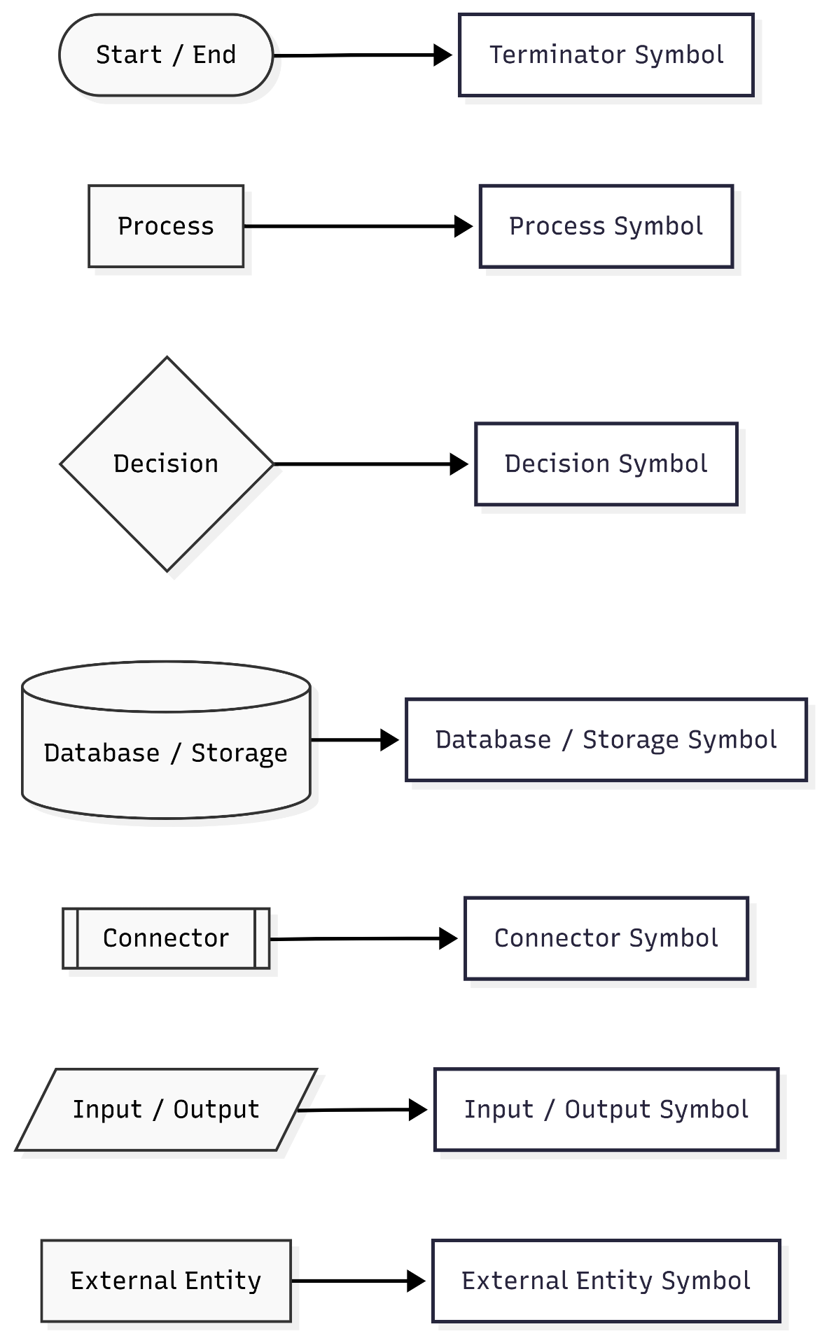

List of Figures
Sr No. | Figure Name | Page No.
1 | Context Diagram | 13
2 | 0-Level DFD | 15
3 | 1-Level DFD | 16
4 | 2-Level DFD | 17
5 | Entity Relationship Diagram | 19
6 | Flow Chart | 24
7 | SnapShots | 27-30
8 | Database & tables | 30-32

CHAPTER – 1

Introduction
In today’s digital world, data is being created and shared at an incredible pace. From personal files to important organizational documents, a large amount of sensitive information is stored online. This makes security a major concern, as data is always at risk of unauthorized access, breaches, or loss. Many traditional storage systems do not provide strong protection, which creates the need for more secure and reliable solutions.
To address this problem, Secura: Secure File Storage System has been developed. The main goal of Secura is to provide a safe and efficient way for users to store and manage their files while keeping full control over their data. Instead of relying entirely on third-party systems, Secura focuses on protecting user privacy and building trust.
One of the key ideas behind Secura is its privacy-first approach. Files can be encrypted on the user’s side before being stored, which means that even the system itself cannot directly access the actual data. By using strong encryption methods like AES and secure communication protocols such as HTTPS/SSL, the system ensures that data remains confidential during both storage and transfer. This makes it especially useful for users who care deeply about privacy.
The system includes important features such as user login, role-based access control, and secure file operations like upload, download, update, and delete. It also provides an easy-to-use interface so users can manage their files without difficulty. For administrators, there is a dashboard to monitor activity, manage permissions, and maintain security standards. Features like file versioning and audit logs help track changes and keep a record of file history, improving transparency and accountability.
Secura also offers flexibility in how files are stored. Users can choose between local storage or their own cloud services, depending on what they prefer. This reduces dependence on a single system and adds an extra layer of reliability. In addition, search and filter options make it easier to find files quickly, improving overall usability.
The system was developed following a proper software development process, including planning, design, implementation, testing, and deployment. Different technologies were combined to create a smooth and secure user experience. Testing was carried out to ensure that the system works reliably and can handle potential security risks. Feedback was also considered to improve the system over time.
Although Secura has many useful features, it still has some limitations. For example, it currently does not support advanced collaboration tools and depends on user-managed storage. However, there is scope for future improvements such as multi-cloud support, secure file sharing, mobile apps, and multi-factor authentication. These additions can make the system even stronger and more practical.
In conclusion, Secura is a simple yet effective solution for secure file storage. It combines encryption, access control, and easy file management in one system. More importantly, it encourages users to take responsibility for their own data security instead of depending entirely on external services. By balancing strong security with ease of use, Secura offers a practical approach to managing digital files safely.

CHAPTER – 2
Problem Identification
Digital data is increasing rapidly, and people depend more on online storage. This includes personal, financial, and organizational files. However, many existing systems do not provide strong security, which makes data vulnerable to hacking and unauthorized access.
A major issue with cloud storage is that users do not have full control over their data. Files are stored on third-party servers, often without strong encryption on the user’s side. This creates a risk of data exposure. Weak authentication and poor access control can also lead to misuse.
Another problem is the lack of proper tracking. Many systems do not maintain file history or detect changes, making it hard to identify if data has been modified. Users also face difficulties in managing files due to limited search options and complicated interfaces.
Because of these issues, there is a need for a secure and user-controlled system. Secura solves this by using encryption, access control, and flexible storage options.
Feasibility Study
Technical Feasibility
The system can be built using common technologies like web development tools and encryption methods such as AES. Secure communication using HTTPS is already supported. Integration with local and cloud storage is also possible using existing tools.
Economic Feasibility
The project does not require expensive hardware or software. It can be developed using basic systems and open-source tools. Since it uses user-owned storage, maintenance cost is low.
Operational Feasibility
The system is easy to use and suitable for different users. It provides simple file management and allows administrators to control access. It fits well for real-world use.
Time Feasibility
The project is divided into stages like design, development, and testing. With proper planning, it can be completed within the given time.
CHAPTER – 3
Requirement Analysis
Requirement analysis is about understanding what the system should do and what users actually need. For Secura, the focus is on building a system that is secure, easy to use, and reliable for storing files.
The requirements are based on common problems in existing storage systems, like weak security, lack of user control, and poor file management.
1. Functional Requirements
These are the main features of the system:
User Management
Users should be able to sign up and log in securely. The system should support roles (admin and normal users) so that access is controlled properly.
File Operations
Users can upload, download, update, and delete files easily.
Encryption & Decryption
Files should be encrypted before storage and decrypted only when accessed by the correct user.
Storage Options
Users can store files locally or use their own cloud storage.
File History (Versioning)
The system should keep track of file changes so users can view older versions if needed.
Search & Filter
Users should be able to quickly find files using name, type, or date.
Backup & Recovery
There should be a way to recover files if they are deleted or lost.
Admin Controls
Admins can manage users, assign roles, and monitor system activity.
2. Non-Functional Requirements
These define how well the system should work:
Security
Strong encryption and secure communication must be used to protect data.
Performance
File operations should be fast and smooth.
Scalability
The system should handle more users and files without slowing down.
Usability
The interface should be simple and easy to understand.
Reliability
The system should work consistently without data loss.
Maintainability
The system should be easy to update and improve in the future.
3. System Requirements
To run the system, the user needs:
- A computer, laptop, or mobile device
- A web browser
- Internet connection
- Storage (local or cloud)
- Support for common file types (.pdf, .docx, .jpg, .txt)
4. User Requirements
Individuals – want secure and simple file storage
Businesses – need safe handling of important data
Administrators – need control over users and system activity
Institutions – need a system that can handle large data

CHAPTER – 4
Review of Previous Work
Secure file storage has been widely studied because data security and privacy are major concerns today. Many systems and platforms already exist to store and manage files, but they still have some limitations.
Popular cloud storage platforms like Google Drive, Dropbox, and OneDrive are commonly used because they are easy to access and support file sharing. However, these platforms store data on their own servers, and in most cases, encryption is handled by the service provider. This means users do not have full control over their data, which raises privacy concerns.
Encryption is an important part of secure storage systems. Many existing solutions use AES encryption because it is reliable and efficient. However, in most cases, encryption is done on the server side instead of the user side. This reduces security because the service provider may still have access to the data.
Another common approach is Role-Based Access Control (RBAC), where users are given permissions based on their roles. This helps restrict access and improves security. While RBAC is effective, some systems do not include proper monitoring or logging, which makes it harder to track user activities.
File versioning and audit logs are also used in some systems. Versioning allows users to restore older versions of files, and audit logs help track actions performed on files. These features improve reliability, but they are not always combined with strong security measures like client-side encryption.
Some research has also explored combining local storage with cloud storage. This approach provides more flexibility and reduces dependency on a single system. However, many such systems are complex and not easy for normal users to understand or use. In real-world situations, users often prefer systems that are simple and require minimal setup, which many existing solutions fail to provide.
Overall, existing systems provide useful features, but they still have gaps. Many do not give full control to users, depend heavily on centralized storage, or do not combine all security features in one place. In addition, balancing security with ease of use is still a challenge in many current platforms.
Secura improves on these systems by focusing on user control and security. It uses client-side encryption so that data is protected before storage. It also includes role-based access control, file versioning, and activity tracking. In addition, it supports both local and personal cloud storage, reducing dependence on third-party servers. This makes the system more practical for users who want both security and simplicity.

CHAPTER - 5
Project Description
Secura is a secure file storage system designed to help users store and manage their files safely. The main idea is to give users full control over their data while keeping it protected from unauthorized access.
The system follows a privacy-focused approach where files are encrypted before they are stored. Users can choose to store their data either on their own device or on their personal cloud storage. This reduces dependency on third-party services and keeps sensitive data under user control.
Secura is built using a layered structure. The frontend provides a simple interface where users can sign up, log in, and manage their files. The backend handles important tasks like authentication, file processing, encryption, and communication with storage. A database is used to store user details, file information, and activity records. This separation of components makes the system easier to manage and update in the future.
A key feature of the system is encryption. Files are encrypted before storage and decrypted only when accessed by an authorized user. This ensures that even if data is exposed, it cannot be read without proper access. In addition, encryption is handled on the user side, which further increases privacy and reduces the chances of data misuse.
The system also uses role-based access control. There are different roles such as admin and normal users. Admins can manage users and monitor system activity, while regular users can perform file operations like upload, download, update, and delete based on their permissions. This helps in maintaining proper control and avoiding unauthorized actions.
To make the system more useful, features like file versioning, activity logs, and search options are included. Users can track changes, restore older files, and quickly find files when needed. These features are especially helpful when dealing with large numbers of files or frequent updates.
Secure communication is maintained using HTTPS, which protects data while it is being transferred. Backup and recovery features are also included to prevent data loss. Together, these features ensure that the system remains reliable even in case of errors or unexpected issues.
The project was developed step by step, starting from planning and design to implementation and testing. Each part of the system works together to provide a smooth and secure experience. Regular testing also helps in identifying and fixing issues early.
The system can be improved further by adding features like multi-cloud support, secure file sharing, mobile apps, and extra security layers like multi-factor authentication. These improvements can make the system more flexible and suitable for a wider range of users.

CHAPTER – 6
Design
1. Context Diagram
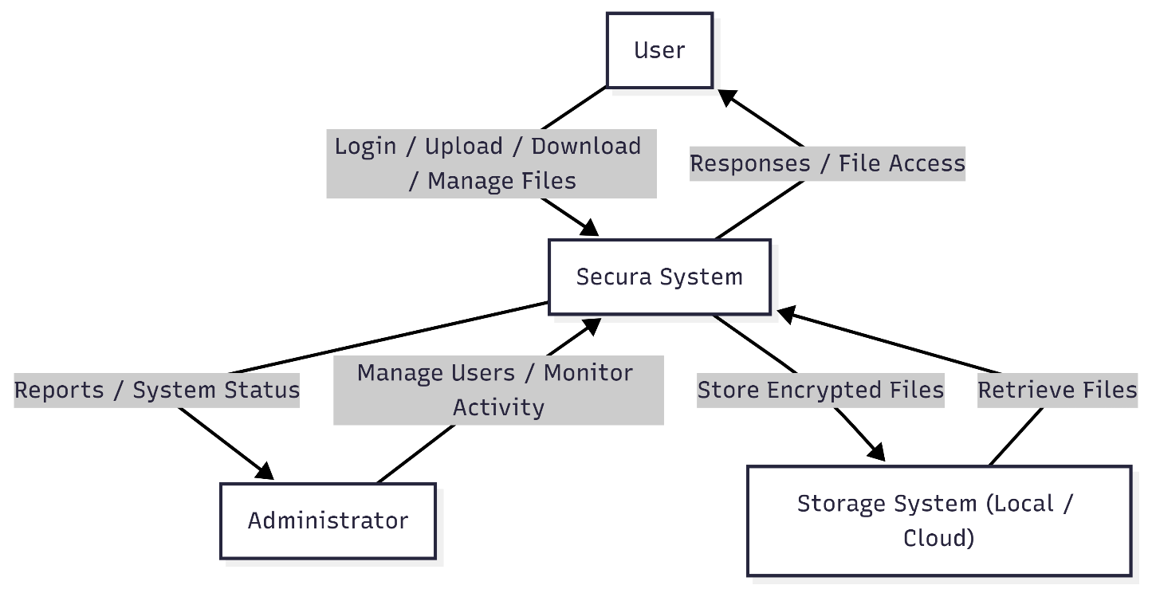
The context diagram shows a high-level view of the Secura system. It represents the entire system as a single unit and focuses on how it interacts with external entities like users, administrators, and storage systems.
Instead of showing internal details, this diagram only shows the flow of data between the system and outside entities. It helps in understanding what goes into the system and what comes out of it.
In Secura, the context diagram mainly shows how users interact with the system for login and file operations, how admins manage the system, and how data is stored in local or cloud storage. This makes it easier to understand the overall working of the system without getting into technical details. It is especially useful during the early design stage to clearly define system boundaries.
Components of the Context Diagram
User
The user is the main entity of the system. Users can register, log in, upload files, download files, and manage their data. They also interact with encryption and decryption features while accessing files.
Administrator
The administrator manages the system. They can control user roles, monitor activities, and ensure that the system is running securely. Admins use a dashboard to perform these tasks.
Storage System (Local / Cloud)
This represents where the files are stored. Files are saved in encrypted form either on the user’s local storage or on cloud storage. This gives flexibility and keeps data under user control.
Main System (Process)
Secura System:
Acts as the central system that handles all operations such as user authentication, file encryption/decryption, file management, and communication with storage systems.
Working
When a user interacts with Secura, the request first goes to the system for authentication. After verification, the user can upload or download files. Files are encrypted before being stored and decrypted when accessed.
Administrators manage users and monitor system activity through the system, which provides logs and reports based on their requests.
All communication between users, admins, and storage is secured using HTTPS/SSL to ensure safe data transfer.
2. Data Flow Diagrams (DFD)
A Data Flow Diagram (DFD) shows how data moves through the system and how it is processed. It helps in understanding how inputs are transformed into outputs inside the system. Unlike the context diagram, DFD breaks the system into smaller parts to show detailed internal working. For Secura, it helps explain how files are processed, encrypted, stored, and retrieved securely.
Level 0 DFD
The Level 0 DFD shows the entire Secura system as a single process and its interaction with external entities.
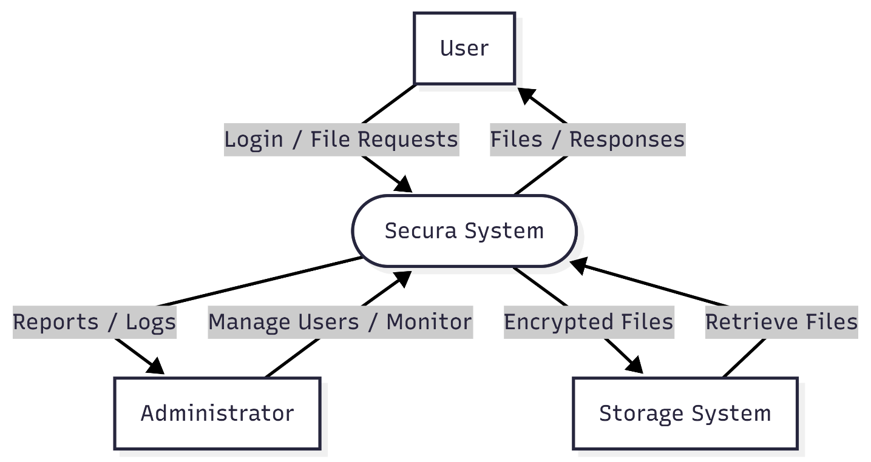
Explanation:
At this level, Secura is represented as one main process that interacts with:
- User: Sends login requests and performs file operations like upload, download, and search.
- Administrator: Manages users, permissions, and monitors system activity.
- Storage System: Stores encrypted files and provides file retrieval when needed.
The system processes all incoming requests, applies security checks, and ensures safe data handling. All communication between entities and the system is handled securely.
Level 1 DFD
The Level 1 DFD breaks the Secura system into smaller internal processes to show how the system works in detail. It explains how data moves between different functions inside the system and how security is maintained at each step.
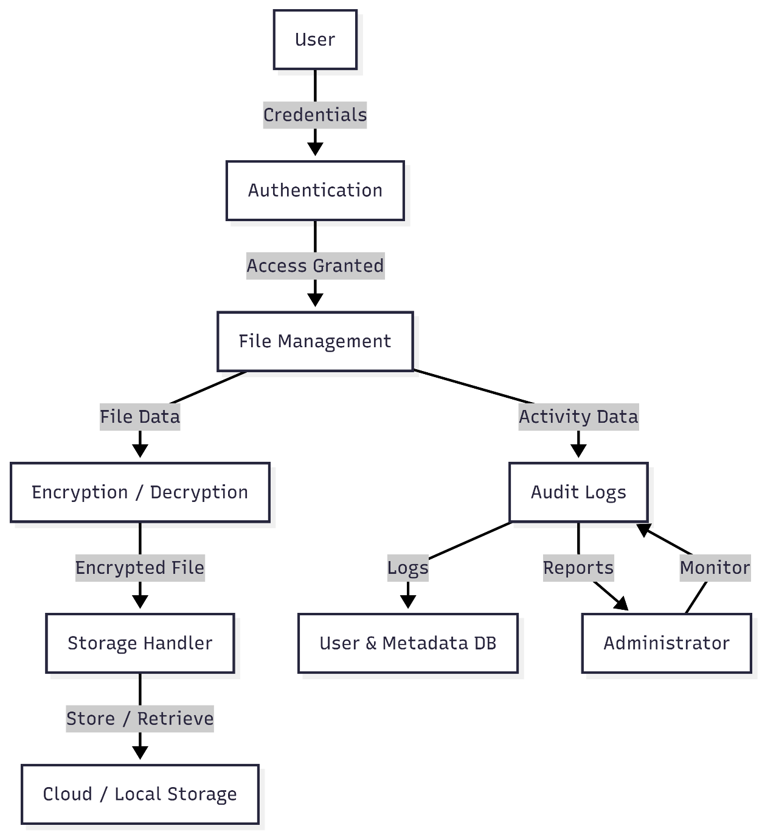
Main Processes
1. User Authentication
Checks user credentials and allows secure login to the system.
2. File Management
Handles file operations like upload, download, update, and delete.
3. Encryption/Decryption
Encrypts files before storage and decrypts them when accessed by authorized users.
4. Storage Handling
Manages storing encrypted files in local or cloud storage and retrieving them when needed.
5. Audit & Logging
Keeps records of user activities for tracking and security purposes.
Explanation
User authentication ensures that only valid users can access the system. After login, users can perform file operations through the file management module. Before any file is stored, it is encrypted to ensure security.
When a file is requested, it is retrieved from storage and decrypted only for authorized access. All actions performed by users are recorded in the audit and logging module, which helps in monitoring system activity.
Storage handling manages the secure transfer of encrypted files between the system and storage.
This level shows how each process works together to maintain security and smooth file management inside Secura.
It also helps in understanding how different modules interact with each other in a structured way, making the system easier to design, analyze, and improve.
Level 2 DFD
The Level 2 DFD shows a detailed view of the file upload and encryption process.
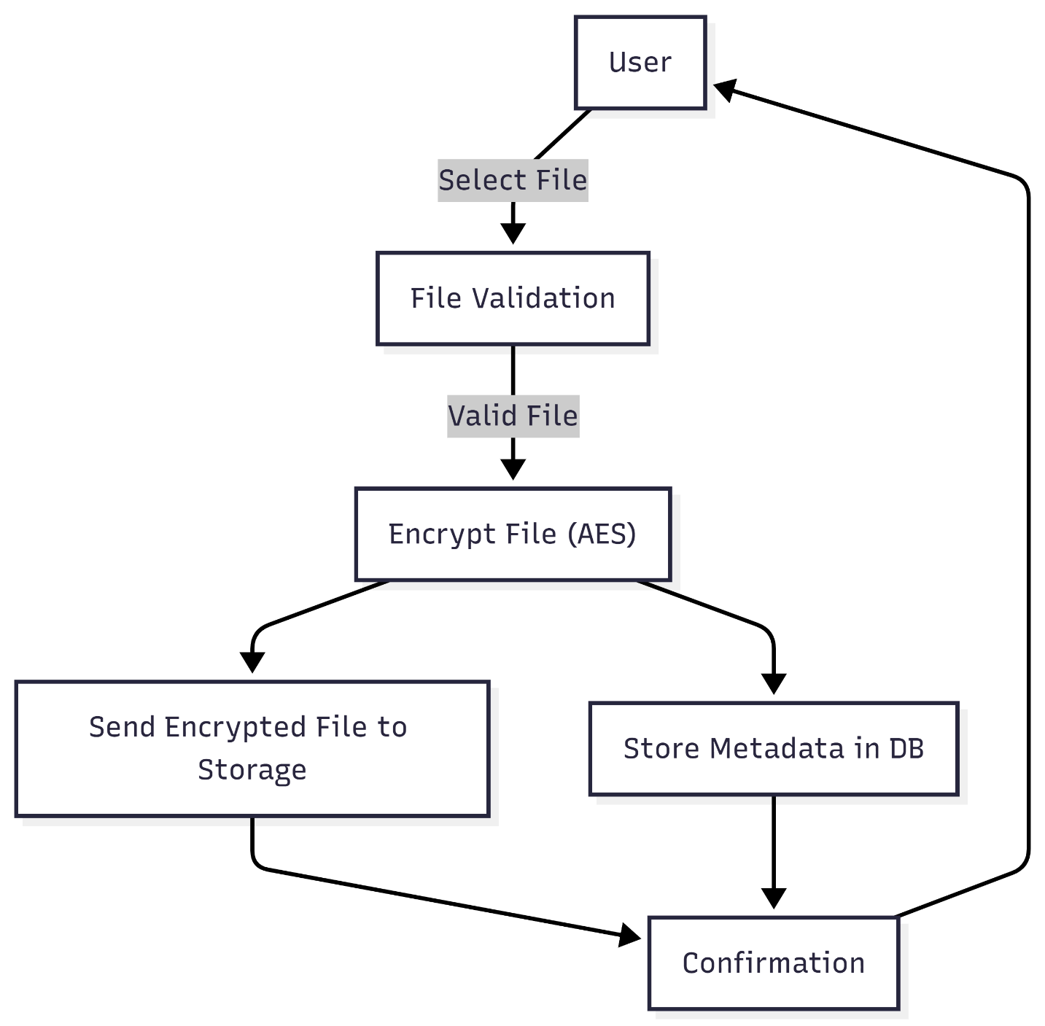
Explanation:
This diagram explains how a file is securely uploaded into the system:
- The user selects a file
- The system validates the file
- The file is encrypted using AES
- File metadata is stored in the database
- The encrypted file is sent to storage
- A confirmation is returned to the user
Each step ensures that the file is handled securely from the moment it is uploaded. The breakdown also makes it easier to understand how the system processes data internally and helps in implementing the workflow correctly.
DFD Overview
The Data Flow Diagrams show how data moves through the Secura system at different levels. They cover user interaction, internal processing, and data storage. The diagrams also highlight key components such as authentication, encryption, storage, and activity tracking, making the system structure clear and easy to understand.
3. Entity Relationship Diagram (ER Diagram)
An ER diagram represents the structure of the database and shows how different entities are related. In the Secura system, it helps organize data for users, files, encryption, and system activity.
Main Entities
User
Stores details of all users.
- User_ID (PK)
- Name
- Email
- Password (hashed)
- Role_ID (FK)
Role
Defines access levels.
- Role_ID (PK)
- Role_Name
File
Stores uploaded file details.
- File_ID (PK)
- File_Name
- File_Type
- Upload_Date
- User_ID (FK)
Encryption_Metadata
Stores encryption details.
- Encryption_ID (PK)
- File_ID (FK)
- Encryption_Type
- Key_Info
Audit_Log
Tracks user activity.
- Log_ID (PK)
- User_ID (FK)
- Action
- Timestamp
Storage
Stores file location.
- Storage_ID (PK)
- Storage_Type
- File_ID (FK)
Relationships
- One Role → Many Users
- One User → Many Files
- One File → One Encryption Metadata
- One File → One Storage
- One User → Many Audit Logs
Diagrams
- User ↔ Role
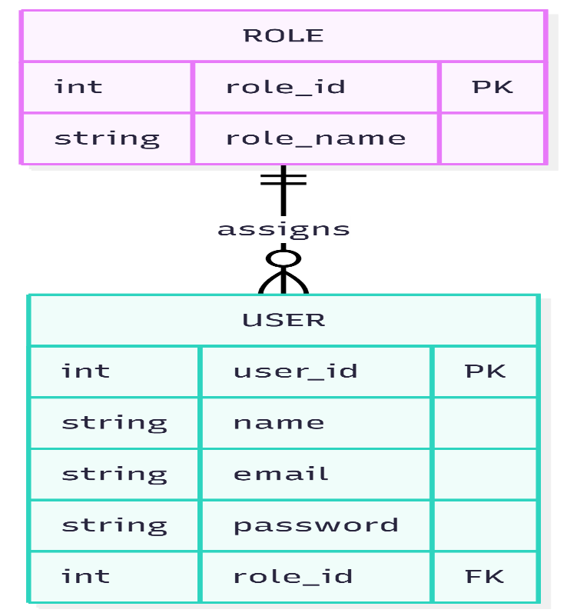
- User ↔ File
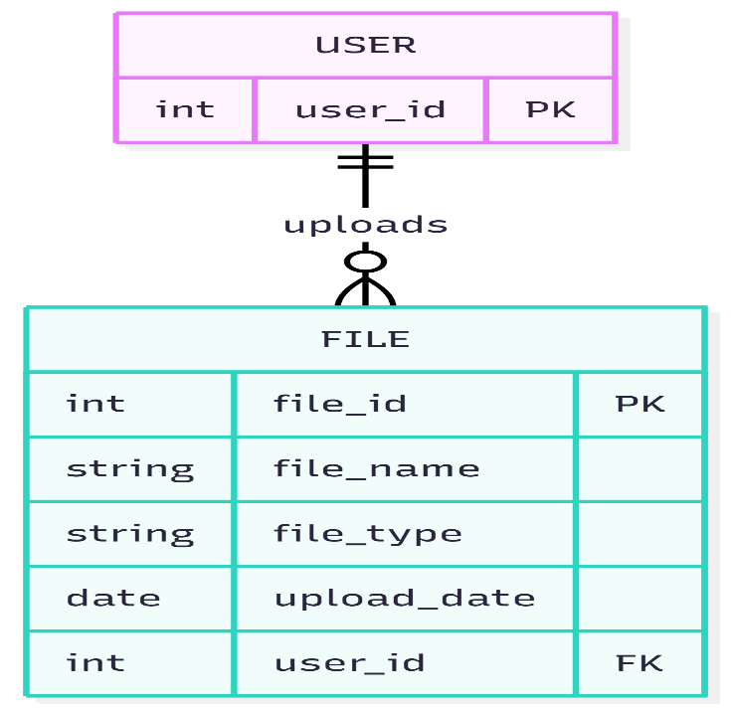
- File ↔ Encryption Metadata
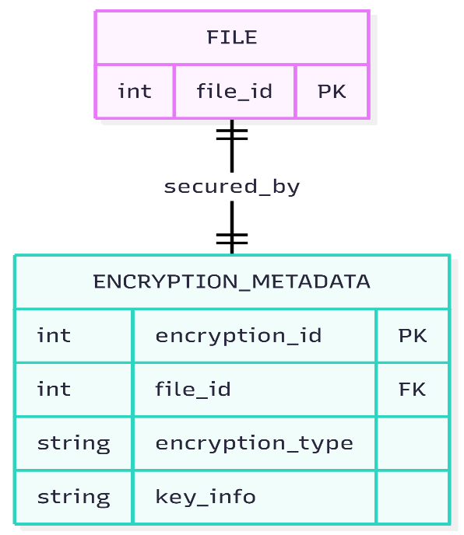
- File ↔ Storage
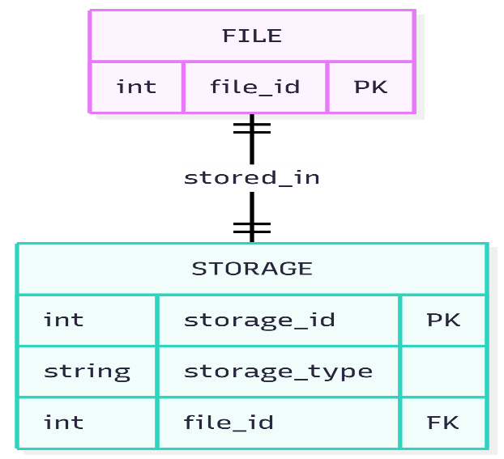
- User ↔ Audit Log
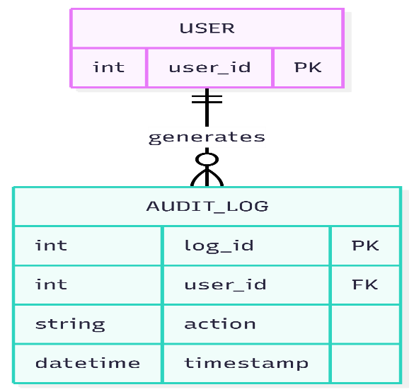
ER Diagram :
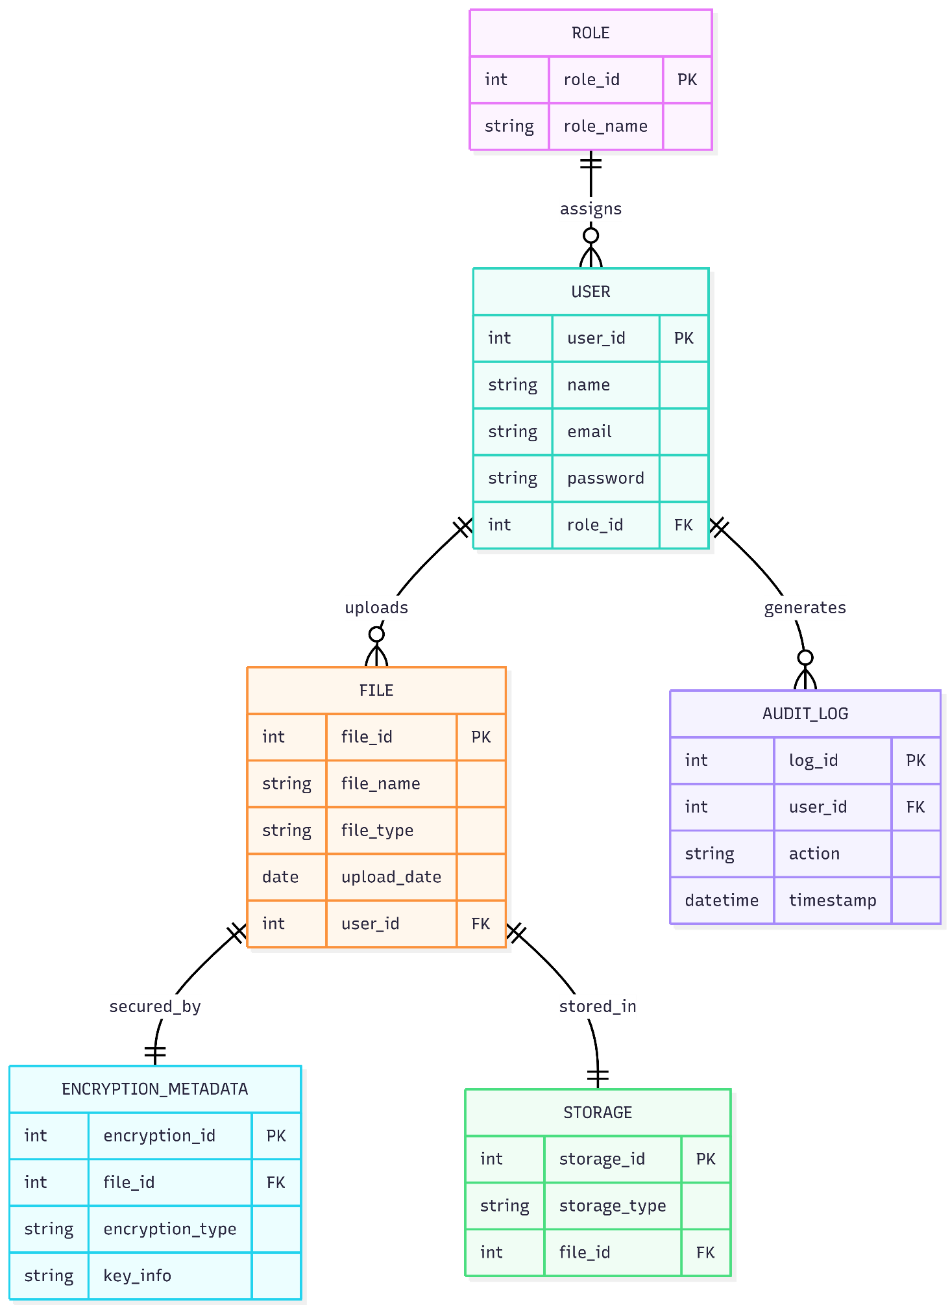
4. Flowchart
A flowchart shows the step-by-step working of a system using symbols and arrows. It helps in understanding how the system processes user actions and handles decisions.
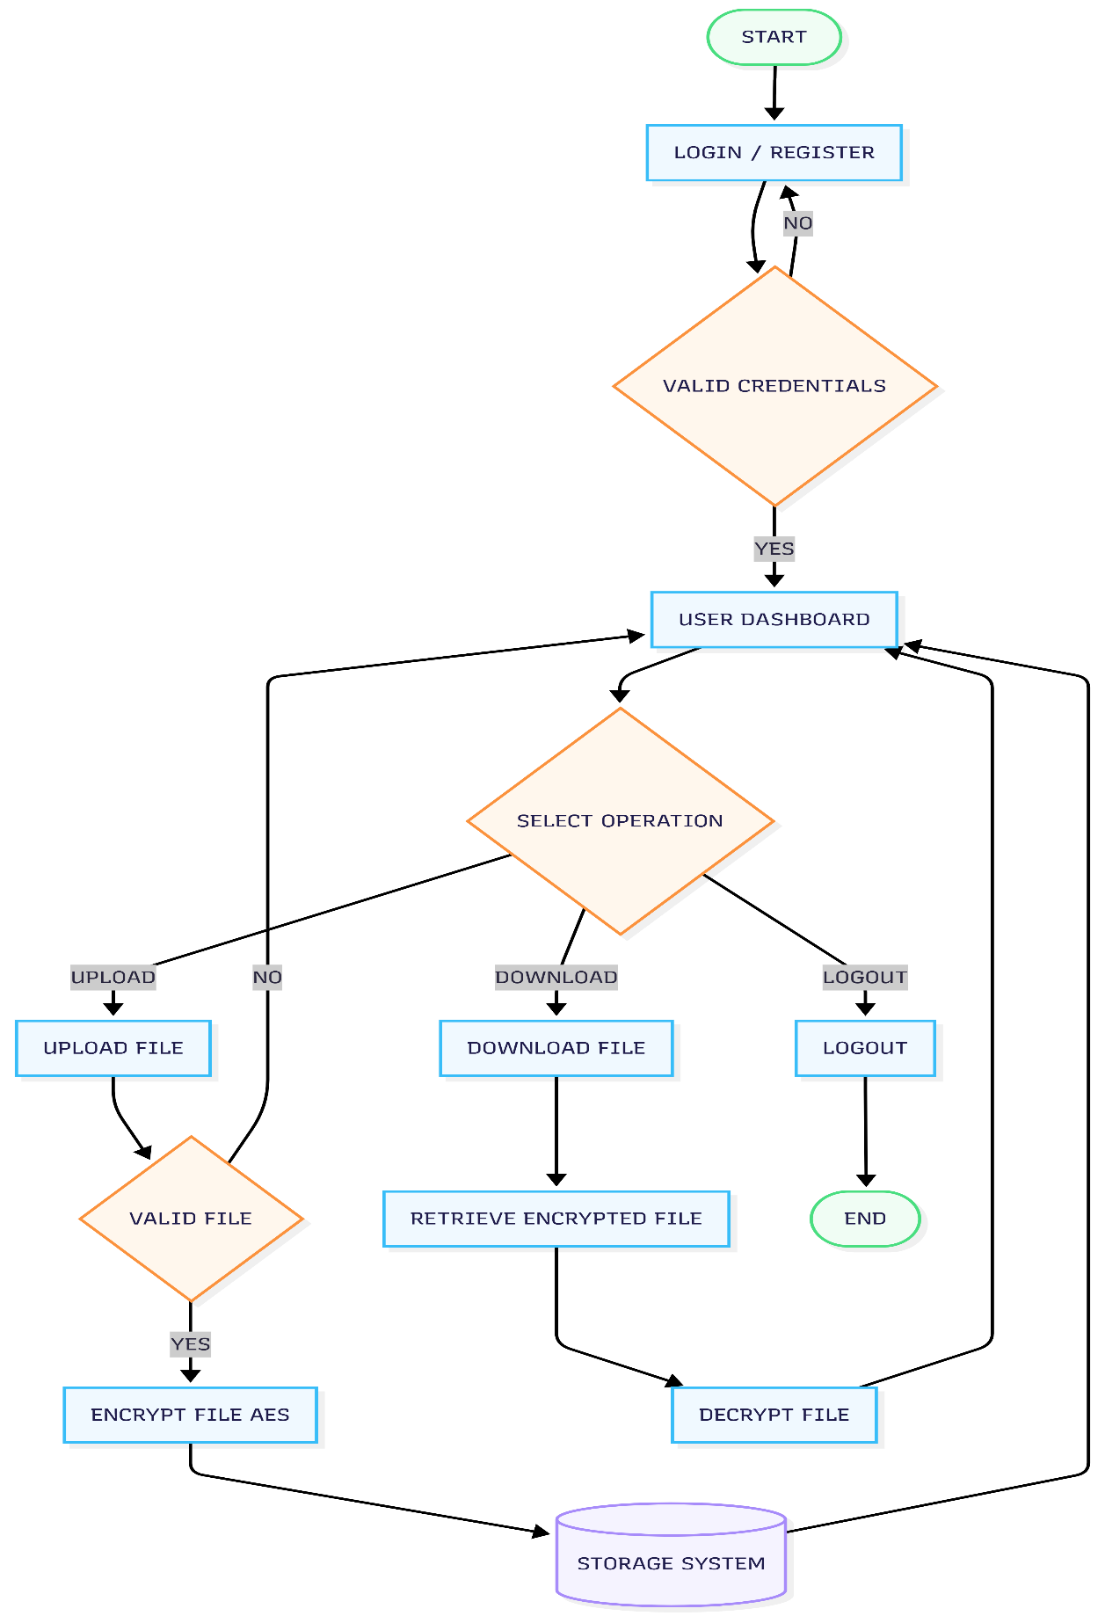
How the Secura Flow Works
- The process starts when the user opens the system
- The user performs Login or Registration
- The system checks credentials
  - If invalid → user retries login
  - If valid → access to dashboard
- From the dashboard, the user selects an operation:
  - Upload File
  - Download File
  - Logout
Upload Process
- User selects a file
- System validates the file
  - If invalid → return to dashboard
  - If valid → continue
- File is encrypted using AES
- File is stored in local/cloud storage
Download Process
- User selects download
- System retrieves encrypted file
- File is decrypted
- File is given to user
Logout
- User logs out
- Process ends
Important Points
- Decision steps handle invalid login and invalid files
- Encryption ensures file security
- Decryption ensures usable output
- Storage can be local or cloud

Snapshots of the Project
This section shows the main user interface screens of the Secura: Secure File Storage System. These snapshots help in understanding how users interact with the system and how different features are used.

1. Login & Registration Page
The Login and Registration page is the entry point of the system. It allows users to securely access or create an account.
Login Section:
Users enter their email and password to log in. The system verifies the credentials and allows access only if they are valid.
Registration Section:
New users can create an account by entering details such as name, email, and password. The password is stored in a secure (hashed) format.
Security Features:
The system uses input validation and shows error messages for invalid credentials. This helps prevent unauthorized access.
This page allows users to easily switch between login and registration.

Dashboard
The Dashboard is shown after a successful login. It provides access to all main features of the system.
File Operations:
Users can upload, download, delete, and view their files.
Search & Filter:
Users can search files by name, type, or date for quick access.
Interface:
The layout is simple and easy to use, making navigation smooth.
Security:
All file operations are connected with encryption and authentication to keep data secure.

Overall
The interface is designed to be simple and easy to use. It allows users to perform all operations smoothly while maintaining security at every step.
5. Snapshots of the Project
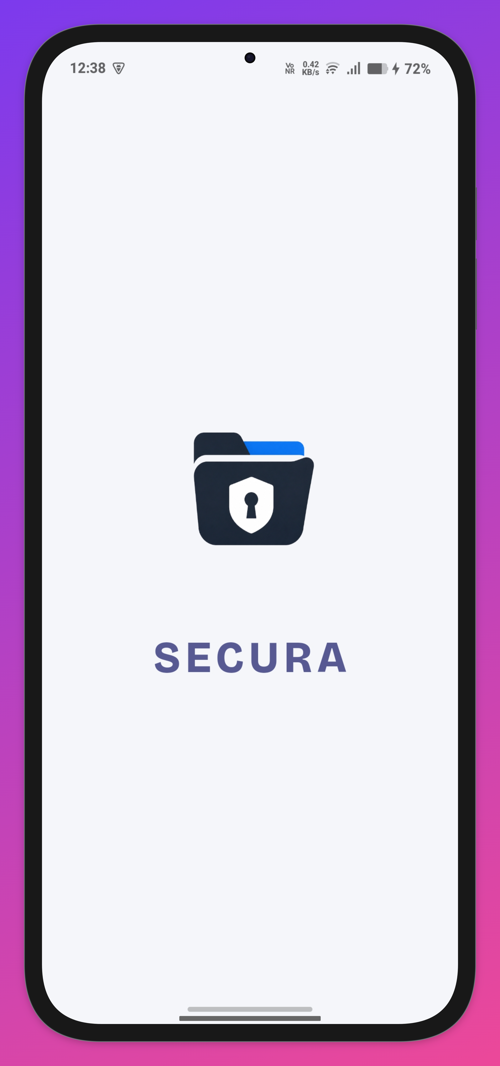

Figure 1: App Opening
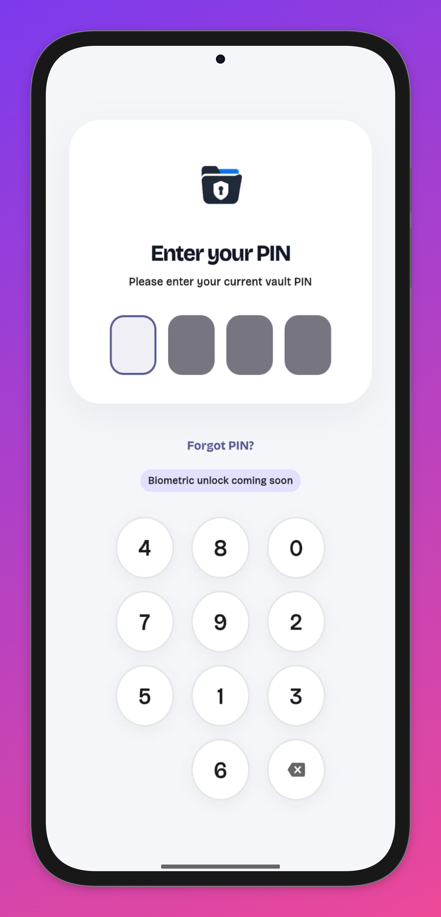

Figure 2: Lock Screen

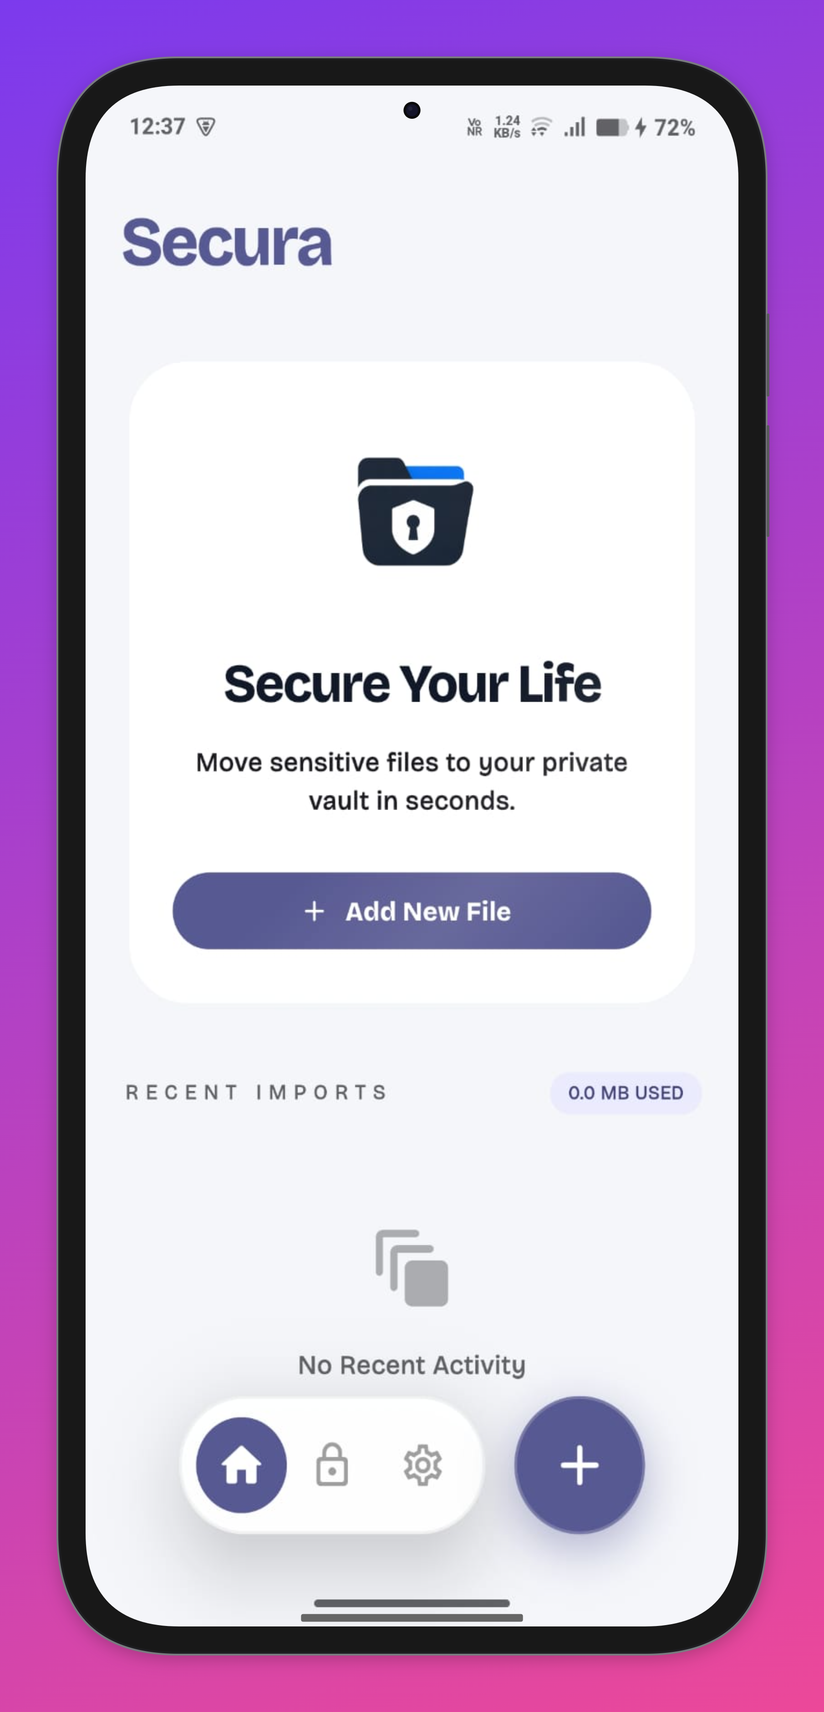

Figure 3: App Home Screen

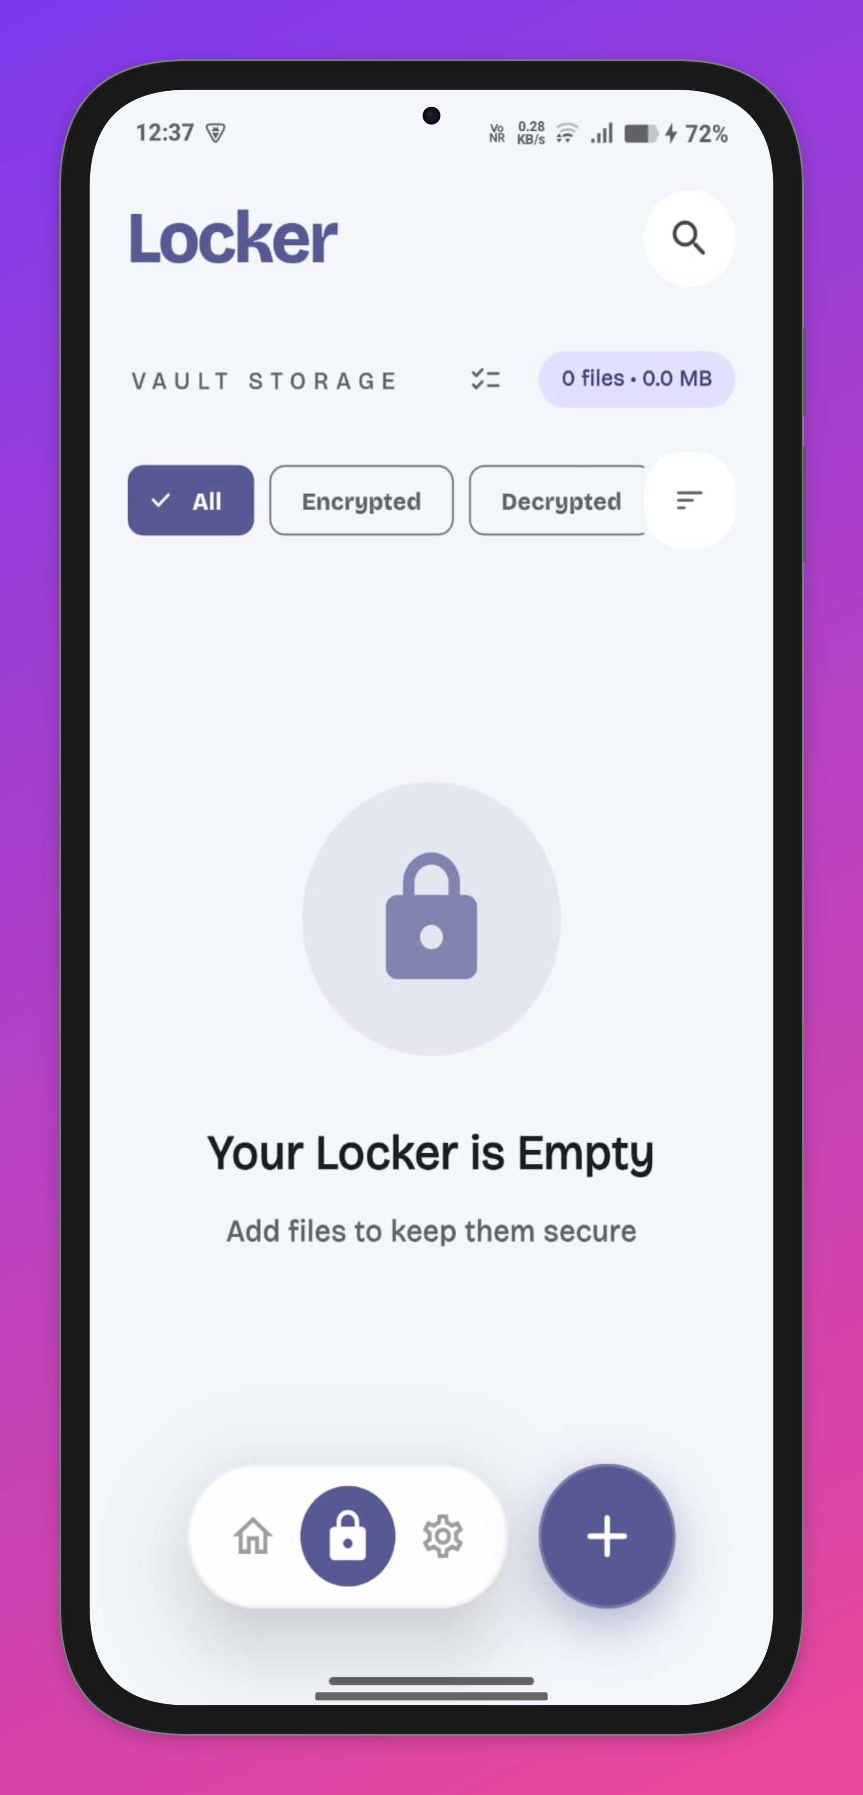

Figure 4: Locker Page
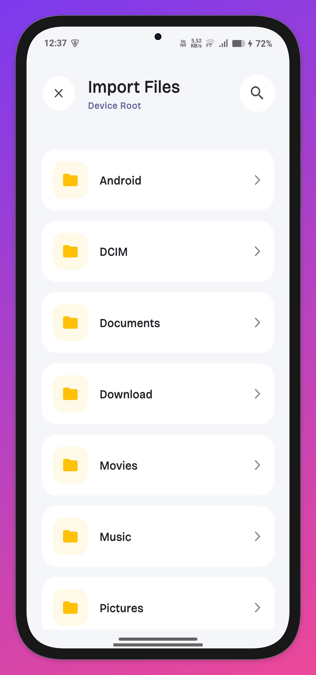
Figure 5: File Importing Page
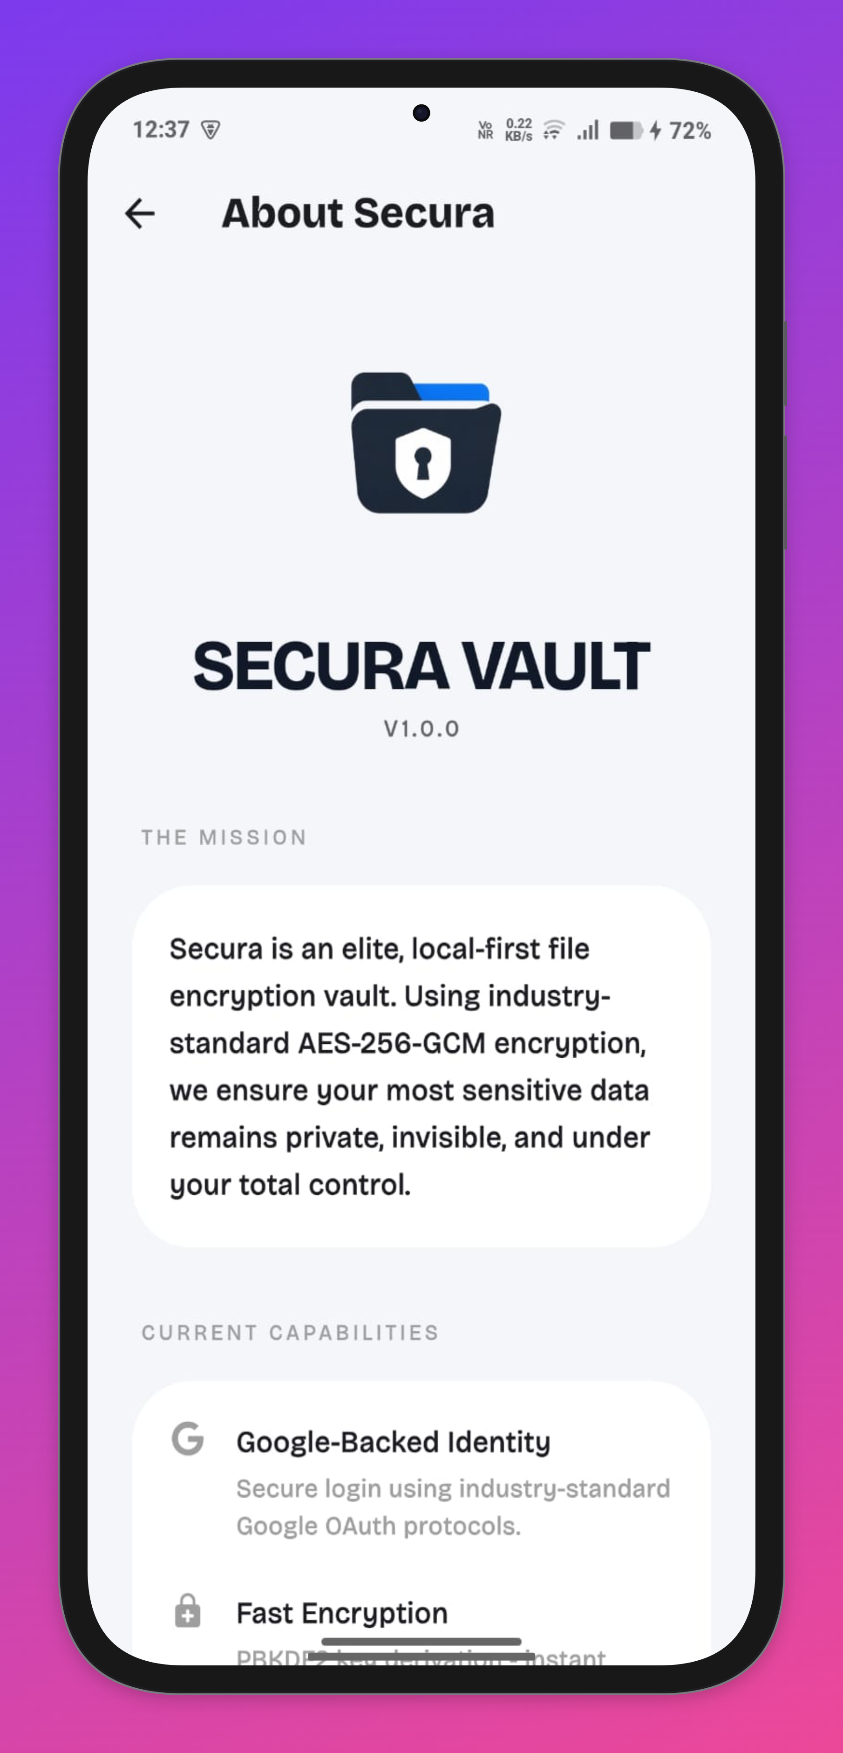

Figure 6: About Page
6. Database & Tables
The database of Secura is designed to efficiently manage users, files, security details, and system activities. It follows a relational structure ensuring data integrity and optimized performance.
1. User Table
Field Name | Data Type | Description
user_id | INT (PK) | Unique identifier for each user
name | VARCHAR | Name of the user
email | VARCHAR | User email (unique)
password | VARCHAR | Hashed password
role_id | INT (FK) | References Role table
2. Role Table
Field Name | Data Type | Description
role_id | INT (PK) | Unique role identifier
role_name | VARCHAR | Role (Admin/User)

3. File Table
Field Name | Data Type | Description
file_id | INT (PK) | Unique file identifier
file_name | VARCHAR | Name of the file
file_type | VARCHAR | Type (pdf, docx, jpg, etc.)
upload_date | DATE | Date of upload
user_id | NT (FK) | Owner of the file

4. Encryption Metadata Table
Field Name | Data Type | Description
encryption_id | INT (PK) | Unique encryption identifier
file_id | INT (FK) | Associated file
encryption_type | VARCHAR | Type of encryption (AES)
key_info | VARCHAR | Encrypted key reference

5. Audit Log Table
Field Name | Data Type | Description
log_id | INT (PK) | Unique log identifier
user_id | INT (PK) | User performing action
action | VARCHAR | Activity (upload/download/delete)
timestamp | DATETIME | Time of activity

6. Storage Table
Field Name | Data Type | Description
storage_id | INT (PK) | Unique storage identifier
storage_type | VARCHAR | Local or Cloud
file_id | INT (FK) | Associated file

The database design of the Secura system is well-structured and secure, ensuring efficient data management. The tables are interconnected through proper relationships, which maintain data consistency and integrity. This design reduces redundancy, improves performance, and allows easy scalability for future enhancements.

CHAPTER - 8

7. Conclusion & Future Work

7.1 Conclusion
The project Secura: Secure File Storage System successfully addresses the need for secure and reliable data storage in today’s digital environment. It integrates strong encryption, secure authentication, and efficient file management into a single platform, ensuring data confidentiality and protection against unauthorized access.
The system uses AES-based encryption to secure files before storage, while allowing users to maintain full control over their data through local or personal cloud storage. This approach reduces dependency on centralized systems and enhances user privacy.
In addition to security, Secura focuses on usability with features such as file upload/download, search and filtering, version control, and activity logs. Role-based access control ensures that only authorized users can perform specific actions, while administrators can monitor and manage the system effectively.
The project was developed using a structured approach, covering analysis, design, implementation, and testing. Along with the web-based platform, an APK application has also been developed to improve accessibility and user experience.
Overall, Secura is a scalable and practical solution suitable for individuals and organizations, offering a balance between security, performance, and ease of use.

7.2 Future Work
Although Secura provides a strong foundation, several enhancements can further improve its capabilities:
- Multi-Cloud Integration:
Support for multiple cloud platforms for better flexibility
- Encrypted File Sharing:
Secure sharing with controlled access
- Multi-Factor Authentication (MFA):
Additional security through OTP or biometrics
- Mobile Application Enhancement:
Expanding features of the existing APK app
- Real-Time Collaboration:
Shared workspaces and collaborative editing
- AI-Based File Organization:
Smart categorization and recommendations
- Advanced Security Measures:
Intrusion detection and improved encryption techniques
With these improvements, Secura has the potential to evolve into a more advanced and industry-ready secure storage solution. The project highlights the importance of combining security with usability and serves as a strong step toward building trustworthy digital storage systems.

CHAPTER – 9

References & Appendices

9.1 References
The development of Secura: Secure File Storage System is based on fundamental concepts of cryptography, database management, and modern web technologies. The following resources provided essential guidance during the design and implementation phases:

Books & Academic Resources
- William Stallings – Cryptography and Network Security: Principles and Practice
- Korth, Silberschatz & Sudarshan – Database System Concepts
- Ian Sommerville – Software Engineering

Online Documentation & Resources
- MongoDB Official Documentation – https://www.mongodb.com/docs/
- Node.js Documentation – https://nodejs.org/
- Express.js Documentation – https://expressjs.com/
- React Documentation – https://react.dev/

Security & Encryption Standards
- NIST (National Institute of Standards and Technology) – AES Encryption Standard
- OWASP (Open Web Application Security Project) – Secure Web Application Guidelines

Research Papers & Articles
- Studies on cloud security and data encryption techniques
- Research on Role-Based Access Control (RBAC) systems
- Articles on secure file storage and privacy-preserving systems

9.2 Appendices
The appendices provide additional technical details and supporting information that complement the main project documentation.

Appendix A: Technology Stack
Component | Technology Used
Frontend | React.js
Backend | Node.js, Express.js
Database | MongoDB
Encryption | AES Algorithm
Communication | HTTPS / SSL

Appendix B: Sample Database Structure (MongoDB Collections)
Since Secura uses a NoSQL database (MongoDB), data is organized into collections instead of traditional tables.
- Users Collection
Stores user credentials, roles, and authentication details.
- Files Collection
Contains file metadata such as file name, size, owner, and storage path.
- Encryption Metadata Collection
Maintains encryption-related information such as keys (secured), initialization vectors, and encryption status.
- Audit Logs Collection
Records user activities such as login attempts, file uploads/downloads, and system actions for monitoring and security.

Appendix C: Key Features Summary
- Secure file encryption using AES
- Role-Based Access Control (RBAC)
- Flexible data storage using MongoDB
- Support for local and cloud storage
- Audit logs and activity tracking
- User-friendly interface (Web + APK application)

Appendix D: Future Enhancements (Technical)
- Integration with multiple cloud service APIs
- Implementation of JWT-based authentication
- Multi-Factor Authentication (MFA)
- Deployment on cloud platforms such as AWS and Azure
- Performance optimization and scalability improvements
The references and appendices provide the necessary theoretical background and technical support for the Secura project. They also serve as a foundation for understanding the system design and future enhancements.
Biodata of Group Members

1. Umang Gupta (Team Leader)

Introduction
Umang Gupta is a BCA student in the 3rd year (6th semester) at Integral University, Lucknow. He serves as the Team Leader of the Secura project, guiding the team, managing development flow, and ensuring successful project execution. He has strong interest in full-stack development and cybersecurity.

Academic Details
- Course: Bachelor of Computer Applications (BCA)
- Year/Semester: 3rd Year / 6th Semester
- College: Integral University, Lucknow

Contact Information
- Address: Faizabad
- Contact No.: +91 9621272014

Skills
- React.js, Node.js, MongoDB
- HTML, CSS, JavaScript
- Terminal, Linux

Hobbies
- Internet surfing
- Learning new things

Aim
- To become a Cyber Security Engineer and Developer

2. Tribhuvan Pratap Singh (Frontend UI/UX Developer)

Introduction
Tribhuvan Pratap Singh is a BCA student in the 3rd year (6th semester) at Integral University, Lucknow. He is responsible for Frontend UI/UX development in the Secura project, focusing on designing user-friendly and interactive interfaces.

Academic Details
- Course: Bachelor of Computer Applications (BCA)
- Year/Semester: 3rd Year / 6th Semester
- College: Integral University, Lucknow

Contact Information
- Address: Lucknow
- Contact No.: 8175053778
- Email ID: tribhuvanpratapsingh72@gmail.com

Skills
- Frontend Development

Hobbies
- Exploring the world through technology
- Music
- Gaming

Aim
- To become a Software Engineer

3. Vineet Vikram Rao (Database & Cloud)

Introduction
Vineet Vikram Rao is a BCA student in the 3rd year (6th semester) at Integral University, Lucknow. He is responsible for database management and cloud-related tasks in the Secura project, ensuring efficient data handling and system performance.

Academic Details
- Course: Bachelor of Computer Applications (BCA)
- Year/Semester: 3rd Year / 6th Semester
- College: Integral University, Lucknow

Contact Information
- Address: Lucknow
- Email ID: vineetvikramrao@gmail.com

Skills
- HTML, CSS, SQL
- Basic Bash
- Git & GitHub
- Networking

Hobbies
- Gaming
- Watching UFC
- Playing badminton

Aim
- To become a Cloud Engineer

4. Vaishnavendra Dhar Dwivedi (Testing)

Introduction
Vaishnavendra Dhar Dwivedi is a BCA student at Integral University, Lucknow, currently in the 3rd year (6th semester). He is responsible for testing and documentation in the Secura project, ensuring system reliability and proper project reporting.

Academic Details
- Course: Bachelor of Computer Applications (BCA)
- Year/Semester: 3rd Year / 6th Semester
- College: Integral University, Lucknow
- Date of Birth: 10-06-2004

Contact Information
- Address: 44, Sanehi Kunj, Faridi Nagar, Lucknow – 226015
- Contact No.: 8957367096
- Email ID: vaishanad@student.iul.ac.in

Skills
- Data analysis (beginner level)

Hobbies
- Playing sports
- Exploring new achievements

Aim
- To become a skilled Data Analyst

5. Vipul Kumar (Testing & Documentation)

Introduction
Vipul Kumar is a BCA student in the 3rd year (6th semester) at Integral University, Lucknow. He contributes to the Secura project in testing and documentation, helping maintain accuracy and quality of the system.

Academic Details
- Course: Bachelor of Computer Applications (BCA)
- Year/Semester: 3rd Year / 6th Semester
- College: Integral University, Lucknow

Contact Information
- Address: Muzaffarpur, Bihar
- Contact No.: 9508618201

Skills
- HTML, CSS
- C, C++

Hobbies
- Cricket
- Badminton
- Eating

Aim
- To secure a Government Job
The team consists of dedicated and skilled individuals with clearly defined roles, including leadership, frontend development, database and cloud management, and testing and documentation. Each member contributes uniquely to the success of the Secura project and shares a strong commitment to building a secure and efficient system.

